ROOM MANAGEMENT.
Hotel Room Management System Project Report
Name: Bulwadda Titus Trevor
Course: CSC1204_2026 Database Management
Date: 13th April 2026.

Hotel Room Management System Project Report.
This project set out to design and implement a Hotel Room Management System (RMS) that solves everyday challenges hotels face—like double bookings, slow check-ins, and confusion over room status. The system brings together all the moving parts of hotel operations into one database: guests, rooms, bookings, staff, housekeeping, and maintenance. By modeling these entities and their relationships, we created a structure that keeps data consistent and easy to manage. We then implemented the design in MySQL, populated it with realistic sample data, and ran queries to show how the system can generate useful reports for management. The results demonstrate how the RMS improves efficiency, reduces errors, and supports better decision-making. In short, this project proves how database theory can be applied to solve real hotel management problems in practice.
1. Business Case
Hotels often struggle with manual systems that cause double bookings, idle rooms, delayed housekeeping, and missed revenue. A dedicated Room Management System (RMS) solves these issues by unifying availability tracking, reservations, housekeeping scheduling, dynamic pricing, and maintenance logging.
Key Benefits:
- Prevents double bookings.
- Increases revenue through dynamic pricing.
- Speeds up check-in and check-out processes.
- Automates housekeeping and maintenance scheduling.
- Provides accurate billing and reporting.
2. Entities and Attributes
The RMS database includes the following entities:
- Guests: guest_id, first_name, last_name, email, phone, national_id, nationality, date_of_birth, gender, address.
- Bookings: booking_id, guest_id (FK), room_id (FK), check_in_date, check_out_date, booking_date, booking_status, total_amount, payment_status.
- Room: ROOM_ID, ROOM_NUMBER, FLOOR, ROOM_TYPE_ID (FK), STATUS_ID (FK), CAPACITY, DESCRIPTION, IS_ACTIVE.
- Room_Type: ROOM_TYPE_ID, TYPE_NAME, BED_COUNT, AMENITIES, HAS_WIFI, HAS_AC, HAS_TV, DESCRIPTION.
- Room_Status: STATUS_ID, STATUS_NAME, DESCRIPTION.
- Staff: staff_id, first_name, last_name, role, phone, email, shift, salary, hire_date, status.
- Staff_Role: role_id, ROLE_NAME, PERMISSIONS, DESCRIPTION.
- Housekeeping: id, room_id (FK), staff_id (FK), scheduled_at, status.
- Maintnance: maintnance_id, room_id (FK), staff_id (FK), issue_description, reported_date, resolved_date, status, priority, cost, notes.
3. Relationships and Multiplicities
All relationships are binary and one-to-many:
- Room_Type → Room (1:N)
- Room_Status → Room (1:N)
- Staff_Role → Staff (1:N)
- Guests → Bookings (1:N)
- Room → Bookings (1:N)
- Room → Housekeeping (1:N)
- Staff → Housekeeping (1:N)
- Room → Maintnance (1:N)
- Staff → Maintnance (1:N)
4. ER Diagram
The ER diagram shows all entities, their primary keys, and relationships. Room is central, connecting to Room_Type, Room_Status, Bookings, Housekeeping, and Maintnance. Guests connect to Bookings, Staff connect to Housekeeping and Maintnance, and Bookings connect to Payments.
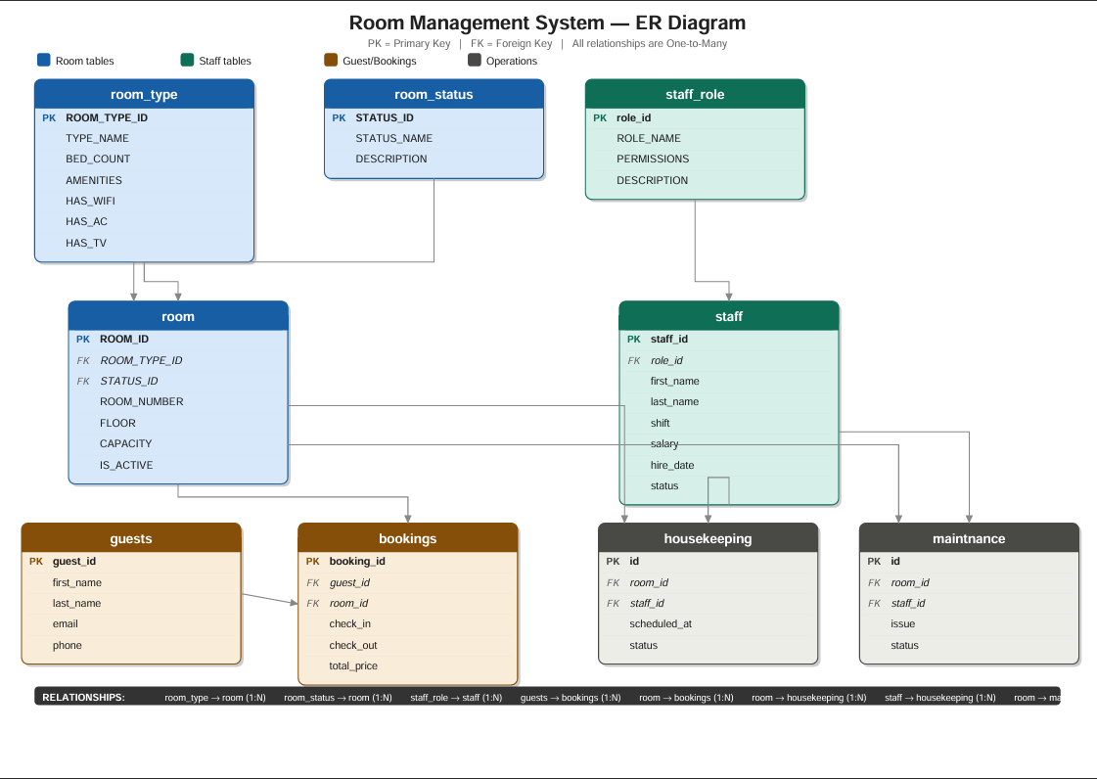

5. User Interface (Dialogue Structure)
- Front Desk Dashboard: Room status grid, today’s check-ins/check-outs, new reservation form, guest search, billing.
- Housekeeping Dashboard: Task list, room status updates, notes, inspection flag.
- Maintenance Dashboard: Open requests, assigned jobs, status updates, room offline flag.
- Management Dashboard: Occupancy overview, revenue summary, pricing controls, staff activity log, reports.
6. Physical Design
Tables created in MySQL with constraints and foreign keys. Schema diagram (Relationships view) shows linked tables.
7. Queries and Reports
Room Status Overview
mysql> SELECT rs.STATUS_NAME, COUNT(r.ROOM_ID) AS total_rooms
-> FROM room r
-> JOIN room_status rs ON r.STATUS_ID = rs.STATUS_ID
-> GROUP BY rs.STATUS_NAME;
+----------------------+-------------+
| STATUS_NAME | total_rooms |
+----------------------+-------------+
| Available | 46 |
| Occupied | 20 |
| Under Maintenance | 7 |
| Cleaning in Progress | 10 |
| Reserved | 12 |
| Out of Order | 5 |
+----------------------+-------------+
6 rows in set (0.01 sec)
Supports management by showing how many rooms are vacant, occupied, or under maintenance.
Staff by Role
sql
mysql> SELECT role, COUNT(staff_id) AS total_staff
-> FROM staff
-> GROUP BY role;
+--------------+-------------+
| role | total_staff |
+--------------+-------------+
| manager | 2 |
| receptionist | 4 |
| housekeeper | 5 |
| maintenance | 4 |
+--------------+-------------+
4 rows in set (0.00 sec)
Helps HR and management understand staff distribution across roles.
Staff Role Permissions
sql
mysql> SELECT ROLE_NAME, PERMISSIONS, DESCRIPTION
-> FROM staff_role;
+-------------------------+-------------------+--------------------------------------------------+
| ROLE_NAME | PERMISSIONS | DESCRIPTION |
+-------------------------+-------------------+--------------------------------------------------+
| Admin | read,write,delete | Has full access to the system |
| Manager | read,write | Can view and edit records |
| Cashier | read | Can only view records |
| Housekeeping Manager | read,write | Manages the housekeeping department |
| Floor Supervisor | read,write | Supervises housekeeping staff per floor |
| Room Attendant | read | Cleans and prepares guest rooms |
| Laundry Staff | read | Manages linen and laundry |
| Maintenance Technician | read,write | Handles room repairs and maintenance |
| Room Inspector | read | Inspects rooms before guest check-in |
| Front Desk Receptionist | read,write | Handles check-in, check-out and room assignments |
| Concierge | read,write | Handles guest requests and complaints |
| Bellboy | read | Assists guests with luggage |
| Night Auditor | read,write | Manages overnight front desk and room reports |
| Room Service Attendant | read | Delivers food and amenities to guest rooms |
| Linen Coordinator | read,write | Manages linen inventory and distribution |
| Pest Control Technician | read | Ensures rooms are free from pests |
| Lost and Found Officer | read,write | Manages items left behind by guests in rooms |
| Room Reservation Agent | read,write | Handles room bookings and cancellations |
| Guest Relations Officer | read,write | Handles guest complaints and room related issues |
| Mini Bar Attendant | read | Restocks and manages mini bar supplies in rooms |
+-------------------------+-------------------+--------------------------------------------------+
20 rows in set (0.00 sec)
Provides clarity on staff responsibilities and access rights.
Room Type Summary
sql

mysql> SELECT rt.TYPE_NAME, COUNT(r.ROOM_ID) AS total_rooms, rt.BED_COUNT, rt.AMENITIES
-> FROM room r
-> JOIN room_type rt ON r.ROOM_TYPE_ID = rt.ROOM_TYPE_ID
-> GROUP BY rt.TYPE_NAME, rt.BED_COUNT, rt.AMENITIES;
+--------------------+-------------+-----------+------------------------------------------------------------------------------------------------------+
| TYPE_NAME | total_rooms | BED_COUNT | AMENITIES |
+--------------------+-------------+-----------+------------------------------------------------------------------------------------------------------+
| Standard Single | 7 | 1 | Wardrobe, Work Desk, Private Bathroom |
| Standard Double | 7 | 2 | Wardrobe, Work Desk, Private Bathroom, Sofa |
| Deluxe Single | 12 | 1 | Wardrobe, Work Desk, Mini Bar, Private Bathroom, Balcony |
| Deluxe Double | 20 | 2 | Wardrobe, Work Desk, Mini Bar, Private Bathroom, Balcony, Sofa |
| Suite | 10 | 3 | Wardrobe, Work Desk, Mini Bar, Jacuzzi, Living Room, Private Bathroom, Balcony |
| Family Room | 14 | 4 | Wardrobe, Work Desk, Mini Bar, Private Bathroom, Kids Play Area, Sofa |
| Executive Suite | 20 | 3 | Wardrobe, Work Desk, Mini Bar, Jacuzzi, Office Space, Private Bathroom, Balcony |
| Presidential Suite | 10 | 4 | Wardrobe, Work Desk, Mini Bar, Jacuzzi, Living Room, Dining Area, Kitchen, Private Bathroom, Balcony |
+--------------------+-------------+-----------+------------------------------------------------------------------------------------------------------+
8 rows in set (0.00 sec)
Supports pricing and marketing by showing room inventory by type.
Active vs Inactive Staff
sql
mysql> SELECT status, COUNT(staff_id) AS total_staff
-> FROM staff
-> GROUP BY status;
+----------+-------------+
| status | total_staff |
+----------+-------------+
| active | 13 |
| on_leave | 1 |
| inactive | 1 |
+----------+-------------+
3 rows in set (0.00 sec)
Helps management track staff availability and plan shifts.
Staff Contact List
sql
mysql> SELECT first_name, last_name, role, phone, email, shift
-> FROM staff
-> ORDER BY role, shift;
+------------+------------+--------------+------------+-----------------------------+-----------+
| first_name | last_name | role | phone | email | shift |
+------------+------------+--------------+------------+-----------------------------+-----------+
| Mary | Nakato | receptionist | 0701234562 | mary.nakato@hotel.com | morning |
| Judith | Twesigye | receptionist | 0701234574 | judith.twesigye@hotel.com | morning |
| Grace | Atuhaire | receptionist | 0701234566 | grace.atuhaire@hotel.com | afternoon |
| Brian | Kayiwa | receptionist | 0701234569 | brian.kayiwa@hotel.com | night |
| Peter | Mugisha | housekeeper | 0701234563 | peter.mugisha@hotel.com | morning |
| Ivan | Mutesasira | housekeeper | 0701234573 | ivan.mutesasira@hotel.com | morning |
| Robert | Ssemwanga | housekeeper | 0701234565 | robert.ssemwanga@hotel.com | afternoon |
| Samuel | Byamugisha | housekeeper | 0701234571 | samuel.byamugisha@hotel.com | afternoon |
| Sarah | Nantongo | housekeeper | 0701234568 | sarah.nantongo@hotel.com | night |
| James | Okello | manager | 0701234561 | james.okello@hotel.com | morning |
| Diana | Nabirye | manager | 0701234570 | diana.nabirye@hotel.com | morning |
| David | Tumusiime | maintenance | 0701234567 | david.tumusiime@hotel.com | morning |
| Esther | Kemigisha | maintenance | 0701234572 | esther.kemigisha@hotel.com | afternoon |
| Alice | Namukasa | maintenance | 0701234564 | alice.namukasa@hotel.com | night |
| Moses | Rukundo | maintenance | 0701234575 | moses.rukundo@hotel.com | night |
+------------+------------+--------------+------------+-----------------------------+-----------+
15 rows in set (0.00 sec)
Provides a quick reference for contacting staff members.
8. Implementation
Tables populated with realistic sample data (100 rooms, guests, bookings, housekeeping, maintenance). Queries executed in MySQL produce result sets that demonstrate system functionality.
9. Conclusion
The Hotel Room Management System integrates multiple entities into a relational model that ensures data consistency, supports operational workflows, and enables management reporting. With realistic sample data, a clear ER diagram, and practical queries, the project demonstrates both theoretical understanding and practical implementation of database systems.
- Connolly, T., & Begg, C. (2015). Database Systems: A Practical Approach to Design, Implementation, and Management (6th ed.). Pearson Education.
- Laudon, K. C., & Laudon, J. P. (2020). Management Information Systems: Managing the Digital Firm (16th ed.). Pearson Education.

